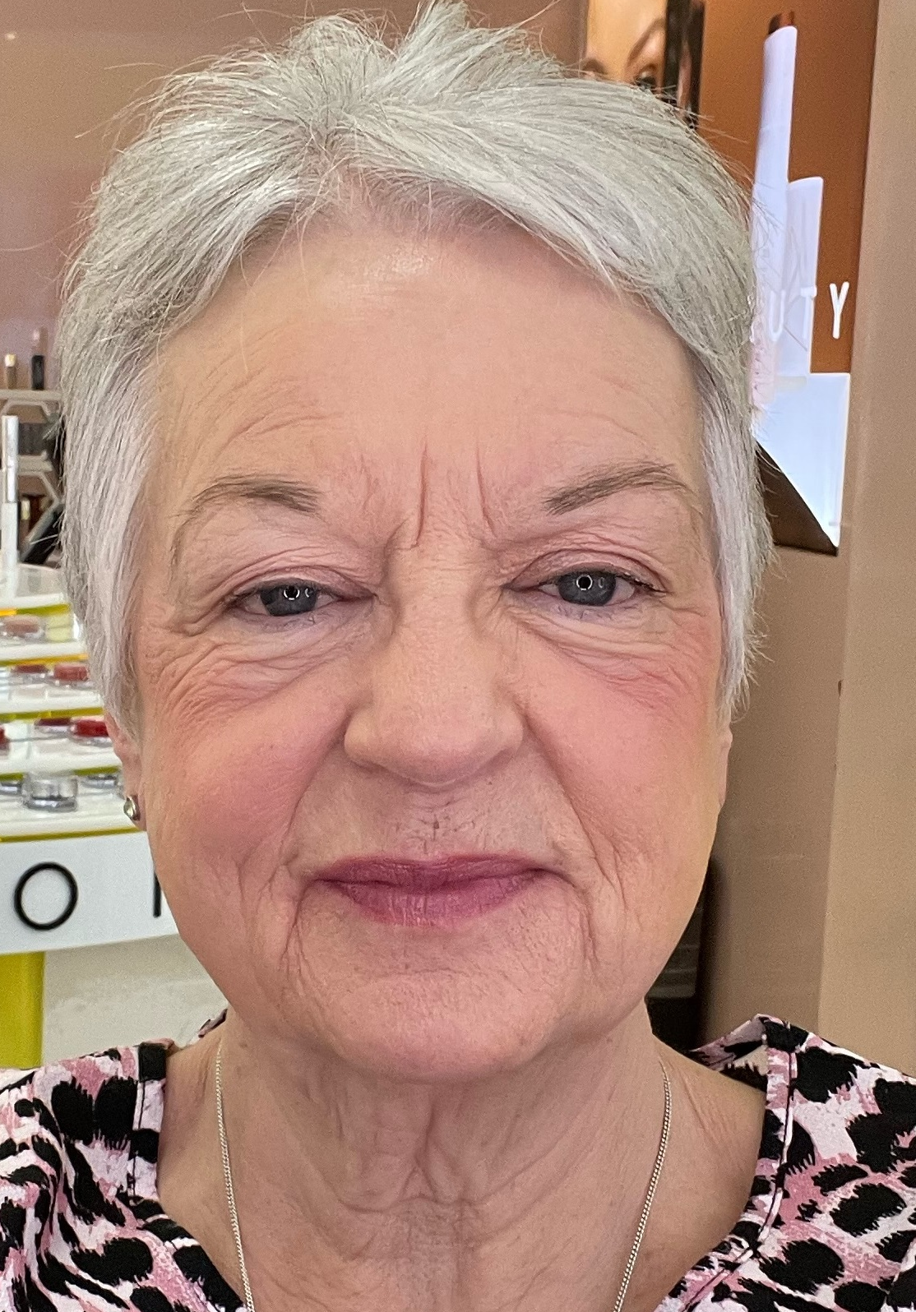
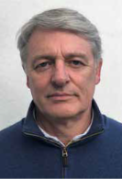

Welcome from the Co-Chairs
We are immensely proud to serve as trustees and Co-Chairs of the Council of Queenscourt Hospice.
Queenscourt isn’t just a building, it’s much more – it is #teamqueenscourt, made up of people with a shared vision. We have 170 staff and nearly 450 volunteers working together as a team to ensure that our vision helps local people achieve the best quality of life at all stages and to ensure that ‘life is for living.’

We have many wide and varied roles in our workforce. Our clinical staff work alongside our doctors and our corporate staff to ensure that we offer the highest quality care possible to the local people of West Lancashire, Southport and Formby and that we raise the funds needed to ensure that Queenscourt is there for our local communities now and in the future.

We also couldn’t survive without our team of nearly 450 volunteers who give their time tirelessly in all manner of roles – from assisting in our kitchen, manning the tills in our shops, lending a hand at our many fundraising events, and much, much more.

For over 30 years, Queenscourt has touched the lives of countless local families through our specialist care and compassionate approach; and over the past few months our ‘compassionate communities’ have shown just how much they are there for us as well, offering financial support, supplies and time.

To keep meeting the needs of those affected by life-limiting illnesses we must work hard to overcome the challenges of the unique economic conditions and to understand the individual nature of each person’s need.

Our continued success can only be assured by effective governance that provides strategic direction and empowers people to make it all happen. This is why our Trustees and the role that they play are so important. If you feel that you have the skills, experience and commitment necessary to help guide Queenscourt on its continuing journey, I hope you will express an interest in our volunteer Trustee vacancies so that we can continue to have the best people leading Queenscourt.

Carol and Terry, Co-Chairs of the Council of Trustees

